***A***

***PROJECT REPORT ON***

***“ONLINE BEAUTY PRODUCTS”***

Submitted to

**Punyashlok Ahilyadevi Holkar Solapur University,**

**Solapur.**

In Partial Fulfilment of The Degree

**“BACHELOR OF COMPUTER APPLICATION”**

**(BCA-III)**

Submitted By

Miss. Sana Gudmitthe (1721)

Miss. Ayesha Shaikh (1718)

**PRIN.K.P. MANGALVEDHEKAR INSTITUTE OF MANAGEMENT, CAREER DEVLOPMENT AND RESEARCH, SOLAPUR. (KPMIM)**

**2021-2022**

***CERTIFICATE OF DIRECTOR***

This is to certify that the project entitled,

“Online Beauty Products”

Has been satisfactorily completed by

**Miss. Sana Gudmitthe (1721)**

**Miss. Ayesha Shaikh (1718)**

In The Partial Fulfilment of the Three-Year Degree Course,

**“BACHELORE OF COMPUTER APPLICATION” (BCA-III)**

Submitted to,

**Punyashlok Ahilyadevi Holkar Solapur University, Solapur.**

Under the guidance of

**Mr. Ritesh Shinde**

Same is hereby approved for the year

2021-2022

Place: Solapur Director:

Date: / /2022

***CERTIFICATE OF HOD***

This is to certify that the project report entitled,

“Online Beauty Products”

Has been satisfactorily completed by

Miss. Sana Gudmitthe (1721)

Miss. Ayesha Shaikh (1718)

In The partial Fulfilment of the Three-Year Degree Course,

**“BACHELOR OF COMPUTER APPLICATI0N” (BCA-III)**

Submitted to,

**Punyashlok Ahilyadevi Holkar Solapur University, Solapur.**

Under The Guidance Of

**Mr. Ritesh Shinde**

same is hereby approved for the year

2021-2022

Place: Solapur Director:

Date: / /2022

**CERTIFICATE OF GUIDE**

This is to certify that the project report entitled

“Online Beauty Products”

Has been satisfactorily completed by

**Miss. Sana Gudmitthe (1721)**

**Miss. Ayesha Shaikh (1718)**

In the Partial Fulfilment of the Three-Year Degree Course of,

**“BACHELOR OF COMPUTER APPLICATION” (BCA-III)**

Submitted to,

**Punyashlok Ahilyadevi Holkar Solapur University, Solapur.**

Under The Guidance Of

**Mr. Ritesh Shinde**

And to the best of my knowledge and belief, that matter presentation this report has not been submitted earlier.

Place: Solapur Sign of Project Guide:

Date: / /2022

**DECLARATION**

We undersigned here by declaring that the project report entitled,

**“Online Beauty Products”**

Written and submitted by us and it is our original work and is done under the guidance of **Mr. Ritesh Shinde.**

The Empirical Findings in this report are

based data collection by us

While preparing this, we have not copied from any report and Website.

We understand that any such copying is entitled to be punished in a way that university authorities deem to be fit.

**Sign Of Students:**

Place: Solapur

Date: / /2022

**Ms. Sana Gudmitthe (1721)**

**Ms. Ayesha Shaikh (1718)**

**ACKNOWLEDGMENT**

A word thanks is much less for the word encouragement which we have received from people going out of the way to make us feel comfortable and to make the things simple. From the bottom of my heart, I would like to Thank the director of the institute **Mr. Pramod Vaidya Sir** and to the HOD of the Computer Department **MR. Santosh Kulkarni Sir** who has given me opportunity to submit this project.

My special Thanks and Sincere gratitude go to our guide **Mr. Ritesh Shinde Sir** who helped me a lot in making this project. Without his constant guidance and constructive.

Criticism throughout the project, it would not have been possible.

**Place:** Solapur **Student’s Signature:**

**Date:** / /2022

**Miss. Sana Gudmitthe (1721)**

**Miss. Ayesha Shaikh (1718)**

**INDEX**

|  |  |  |
| --- | --- | --- |
| **Sr. No** | **TOPIC** | **Page No.** |
| 1 | INTRODUCTION |  |
|  | 1. Problem Definition |  |
|  | 2. objective |  |
|  | 3. Scope Of project |  |
| 2 | SYSTEM ANALYSIS |  |
|  | 1. Feasibility Study |  |
|  | 1. Fact Finding Techniques |  |
| 3 | SYSTEM DESIGN |  |
|  | 1. Data Flow Diagram |  |
|  | 1. Entity Relationship Diagram |  |
|  | 1. Table Design |  |
|  | 1. Form Design |  |
|  | 1. Reports |  |
|  | 1. User Manual |  |
|  | 1. Implementation |  |
|  | 1. Bibliography |  |

**INTRODUCTION**

The “Online Beauty Products” is developed to the overcome the problem of practicing manual system. The application is reduced as much as possible to avoid errors while entering the data.

It also provides error message while entering invalid data. User can handle this system easily. Thus, by this all it proves is it is user-friendly. Online Beauty Products, as described above can lead to error free and fast booking system.

It will store product records, booking records, customer records very easily. We can easily add, update and delete data and also search the records very easily.

**PRESENT SYSTEM**

The existing system is a manual system. Organization takes a huge amount of time for the process completion. When we compare the existing system with the proposed system it will find that searching and upgrading data is a complicated task.

* Due to manual process, it requires more time for completion of any work.
* Wastage of resources including manpower and stationery.
* There is no security of data, more paper work is required.
* As all data is stored in register it increases chances of losing data.
* There is data redundancy problem.

**PROPOSED SYSTEM**

To overcome the problem of the manual system the “Online Beauty Products” will help them in many ways. It will help them to add, updated and deleted the data very easily. The central objectives of this system are to reduce manual work and maintain the records.

Reports will be generated based on different criteria. There is no requirement to store products or registers. The data is directly stored in the database.

**ADVANTAGES OF PROPOSED SYSTEM**

* In the proposed system the admin can store the complete detail of the products, Customers order like id, name, address, mobile number, product details, etc.
* The admin has the admin login who has the rights to perform the operations on product, booking details and he can create reports which provides searching facility.
* The application is reduced as much as possible to avoid errors while entering the data. It also provides error message while entering invalid data. No formal knowledge is needed for the user to use this system. Thus, by all this, we can say is, it is user-friendly.
* This system is faster, secure, automatic and computerized system.
* Minimum time is required.
* Easy to handle.

**SCOPE OF SYSTEM**

* The information can be entered easily.
* Records are easy to maintain using computerized system.
* The paper work will be reduced.
* The reports are easily generated.
* Product i.e., product information is easily updated.
* Sava time and money.

**SYSTEM ANALYSIS**

**Fact Finding Analysis:**

Fact Finding is a process of gathering data and information through number of techniques. The various Fact-Finding techniques are:

**Document Review:**

We observed that which type of documents or information a particular product maintains about Product Booking, Customer, Product Cart, etc. So that we can easily design our system, which is exactly needed by the user.

**Interview:**

The interview of owner should be taken to understand what type of system should be generated and which type of data should be maintained by the system. This is helpful for us to design system from this we get:

1. Identified Requirements.
2. New Ideas and Opinions.
3. Verified and Clear Facts.

**Questionnaires:**

Questions must be well organised from the point of view of respondent.

The question should be asked of fixed format type. The facts and opinions.

Should be cleared and collected from owner from the point of view as they can give all needed information.

**0BSERVATION**

We need to visit the organization and observe the staff while performing activities to understand the flow of documents, working of existing system.

1. The observation should be note down immediately after performing activities.
2. Validation of Facts and data should be done.
3. Time is saved to solve the solution which were already existing.
4. Identify the difficulties which are faced by owner and staff.

**FEASIBILITY STUDY**

The Feasibility Study is a major factor which contributes in the analysis and development of the system. Feasibility Study helps to meet user requirements.

Followings are Three Types of Feasibility Study:

1. Technical feasibility.

2. Economical Feasibility.

3. Operational Feasibility.

**1.Technical Feasibility:**

Technical Feasibility it is the study of hardware and software requirement on which the application is to be used upon.

* Minimum Hardware Requirement –

The Minimum Hardware Requirement for this Software is:

1. Processor: - Intel Processor.
2. RAM: - 2GB (Recommended).
3. Hard Disk: - 150 GB Free Space.

* Minimum Software Requirement –

The Minimum Software Requirements used for this software are:

Front End: **Microsoft Visual Studio 2013**

Back End: **MS SQL Server 2012**

**2.Economical Feasibility:**

Economical analysis is must frequent method used for evaluation the effectiveness of proposed system. More commonly known as cost and benefit analysis. It is very important because main goal of proposed system is to have better result with minimum cost. It is study of cost versus benefit and saving that are expected from proposed system.

The proposed system fulfils all the requirements of existing system. Lot of paper work becomes minimum. In short it will over weigh the existing system in cost compared to benefit since the organization is well equipped with required hardware the project is found to be economically.

**3.Operational Feasibility:**

Operational Feasibility is dependent on Human Resources. Available for the project and involves projecting whether the system will be used if it is developed and implemented.

Operational Feasibility is a measure of how well a proposed system solves the problems, and takes advantages of the opportunities identified during scope definition and how it satisfies the requirements identified in the requirement analysis phase of system level.

**Zero Level DFD: -**

Registration and Buy

Enter Product Info

Customer

Admin

Receipt / Invoice / Bill

Reports

**First Level DFD: -**

Admin

Admin

A

Bill - Details

Bill - Master

Product - Cart

Customer - Login

Customer - Master

Customer

Product - Master

**ERD Diagram: -**

Having Details

Booking Details

Booking Master

Having Details

Having Payment Details

Product Master

Purchase

Pays

Payment

Customer Master

**Screen Layout:**

**Homepage:**

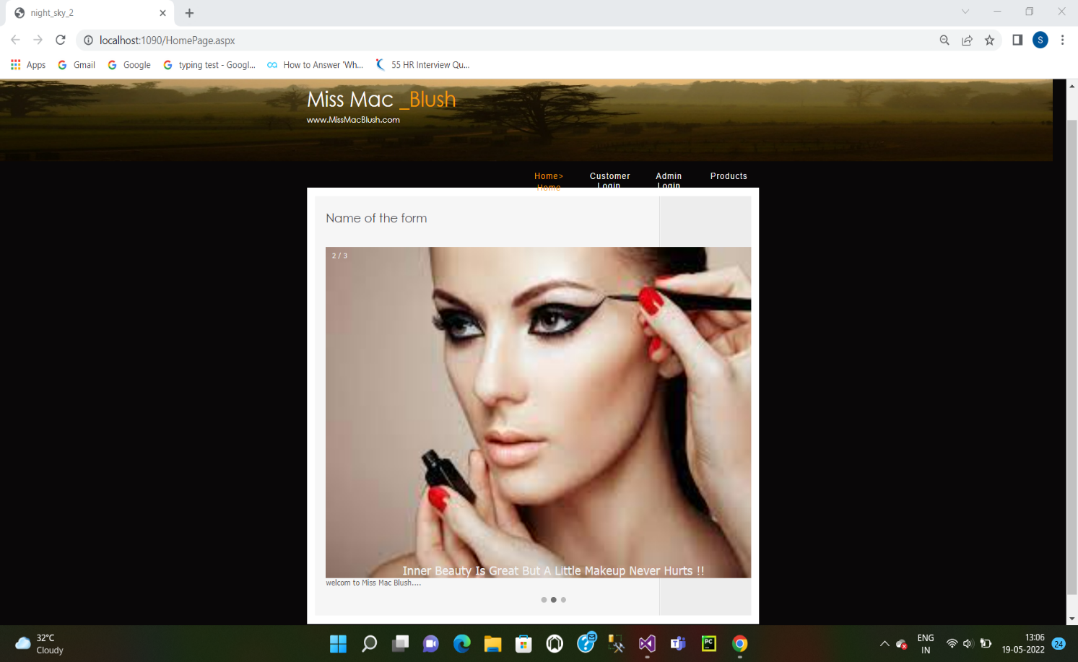

**Customer Login:**

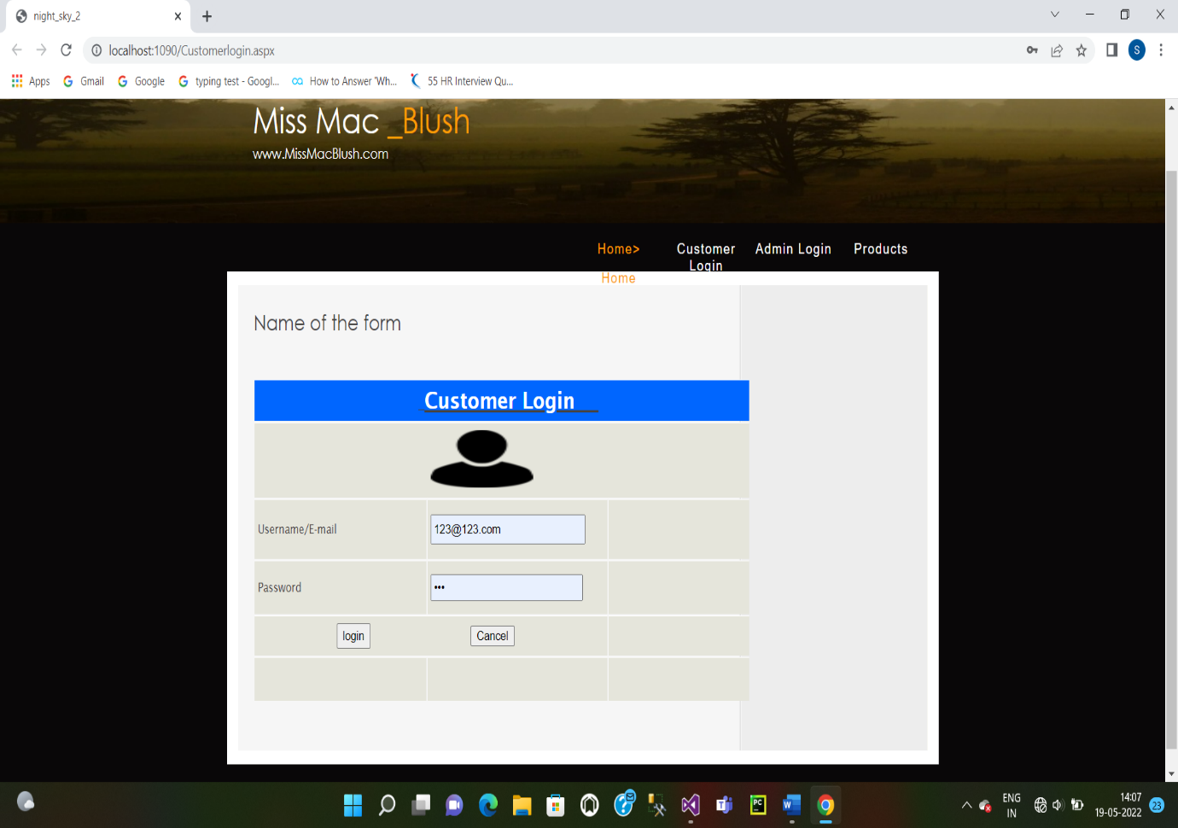

**Customer Registration:**

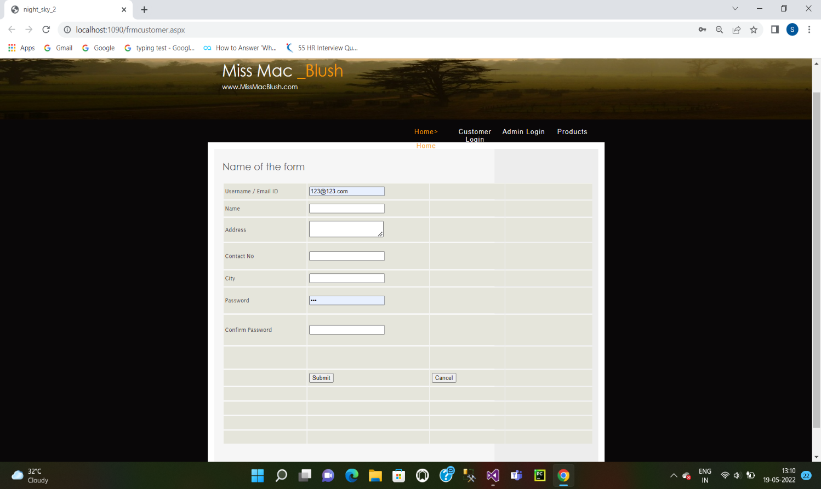

**Admin Login:**

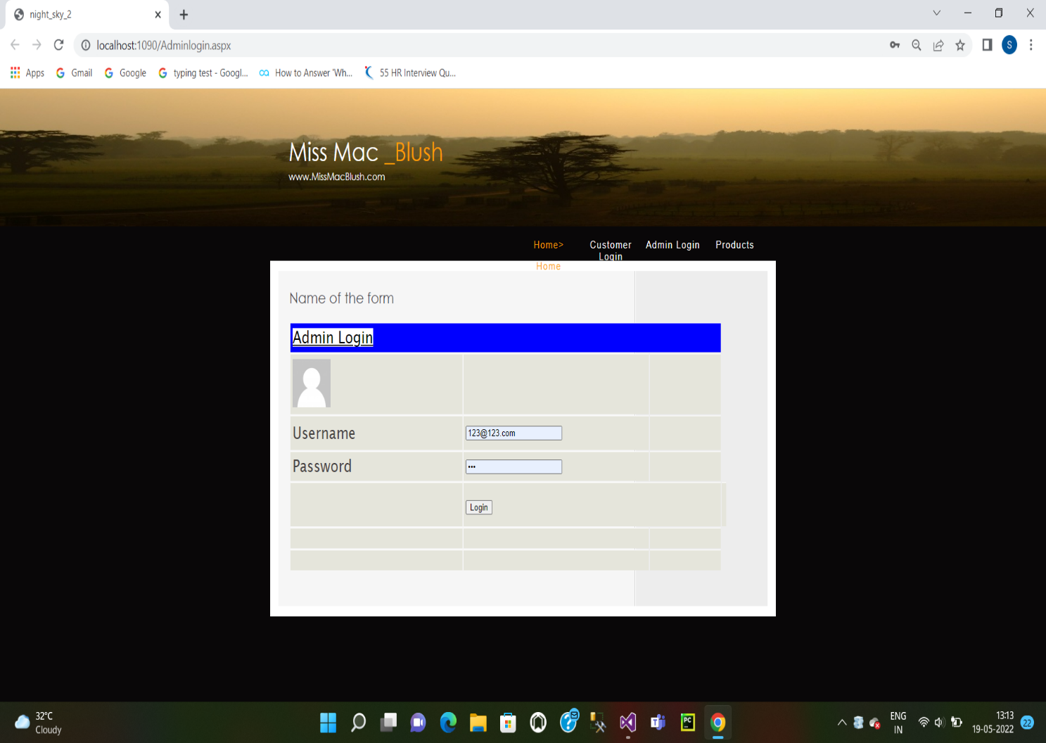

**My Cart:**

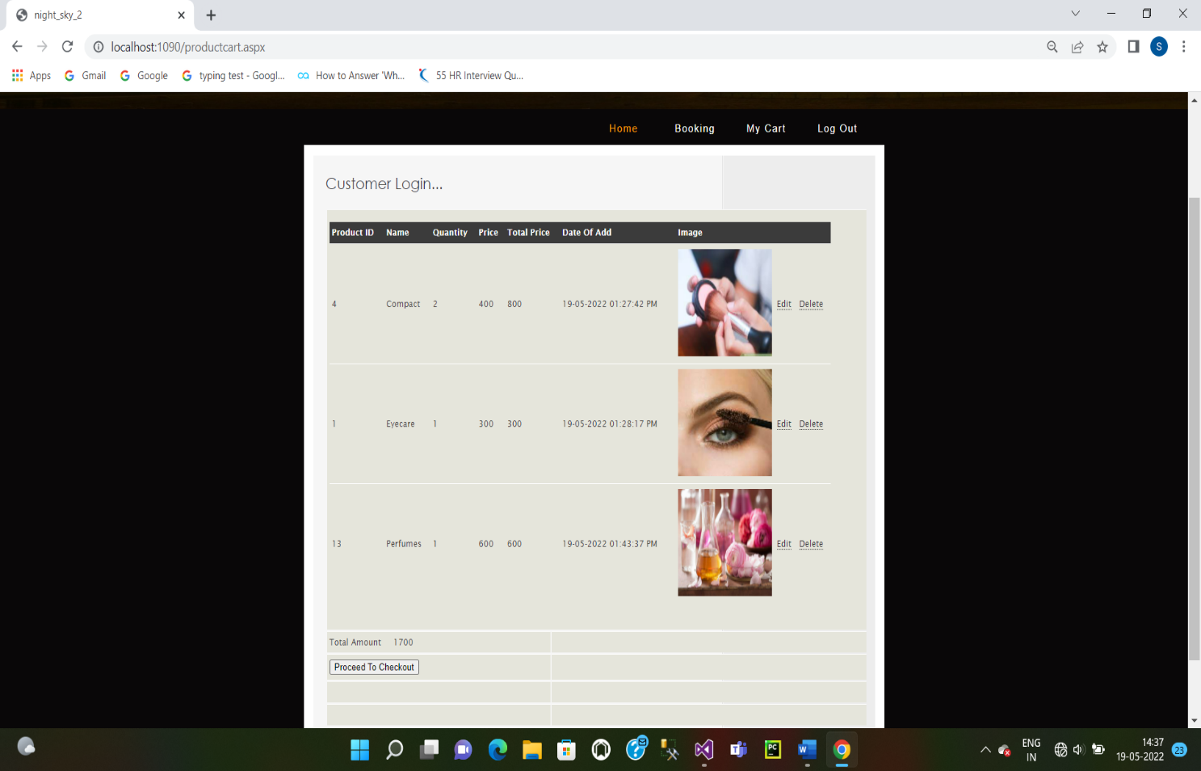

**Product Registration:**

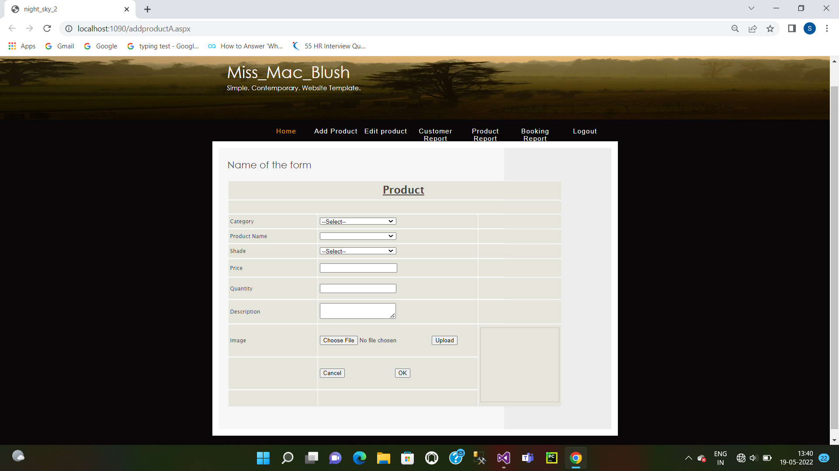

**Edit Products:**

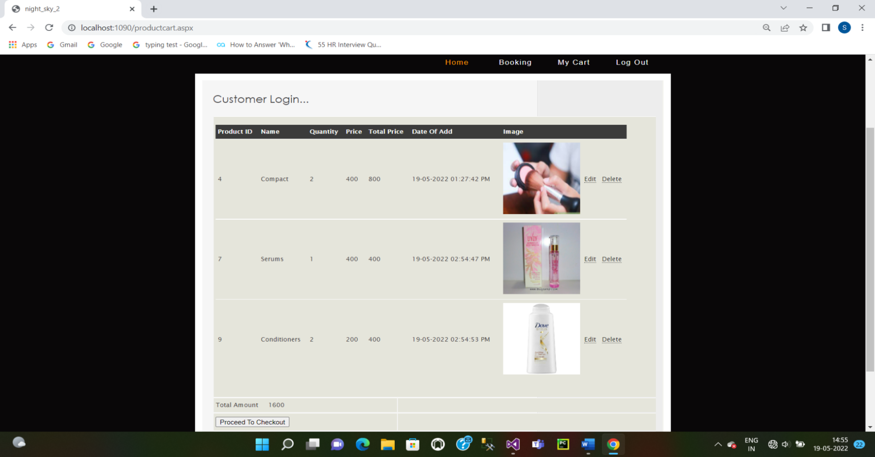

**Customer Report:**

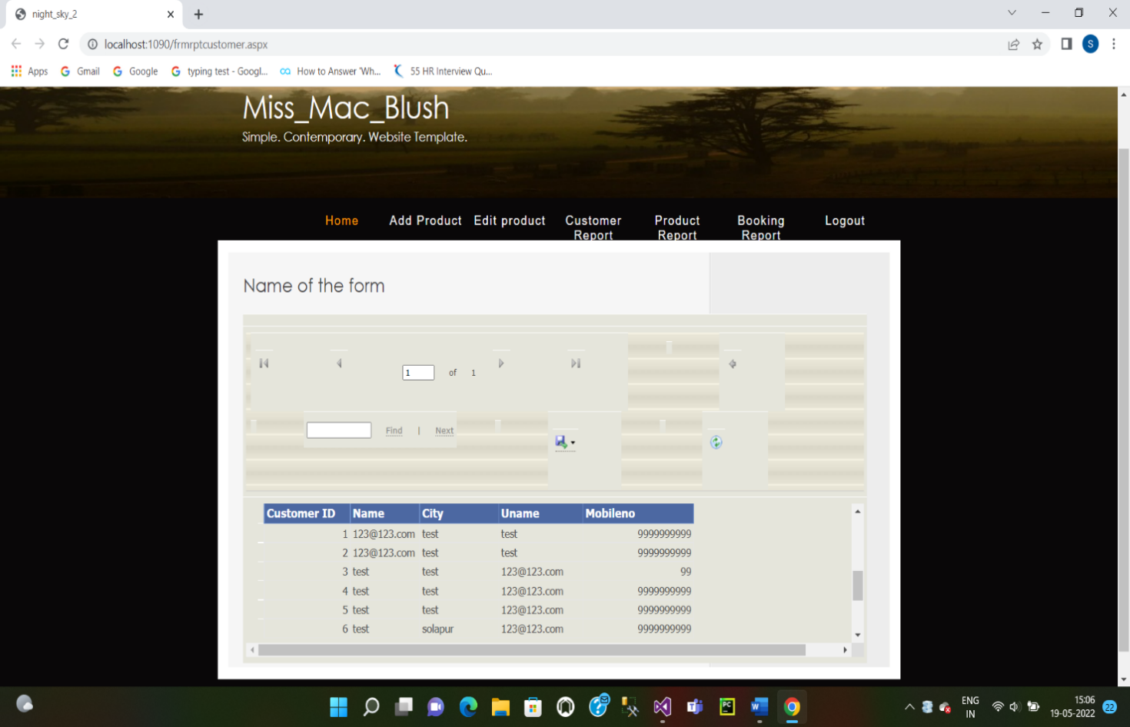

**Booking Report:**

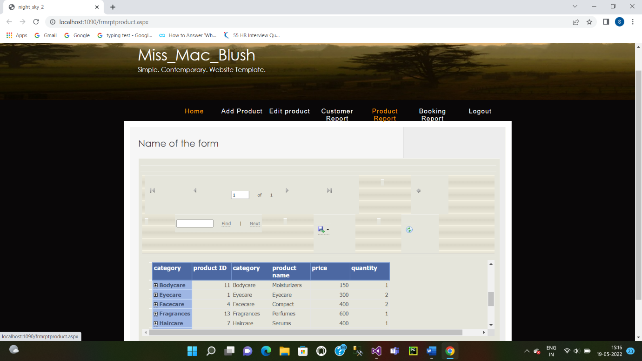

**Payment Reports:**

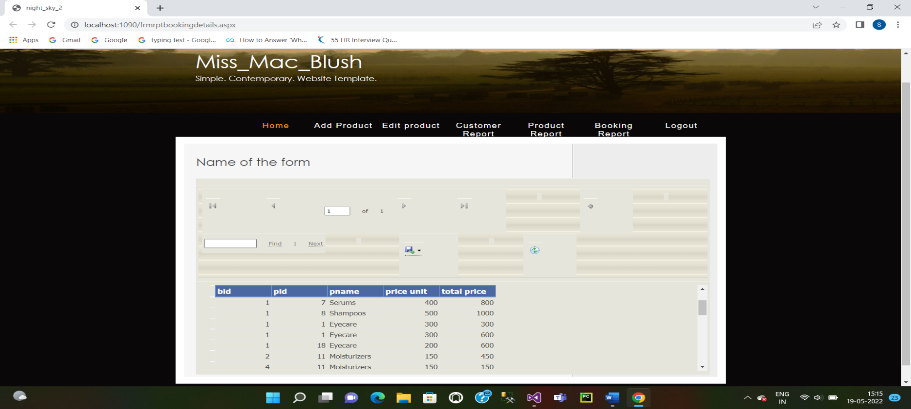

**Design table:**

**Admin Login Table:**

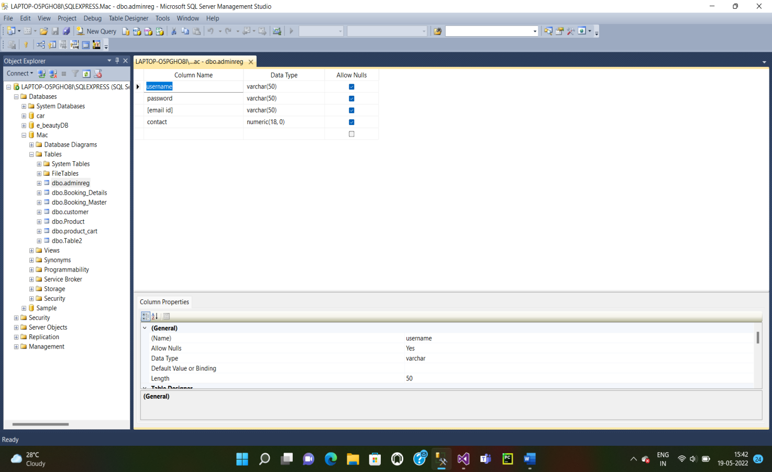

**Product Cart Table:**

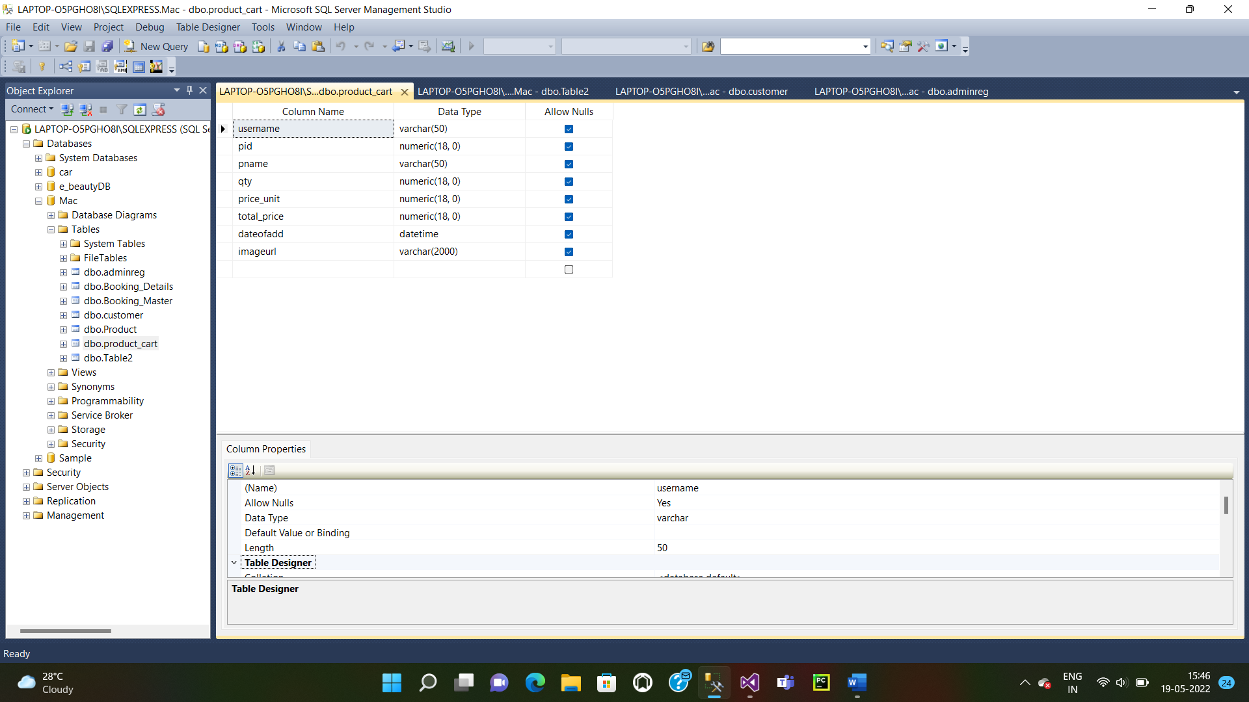

**Customer Registration Table:**

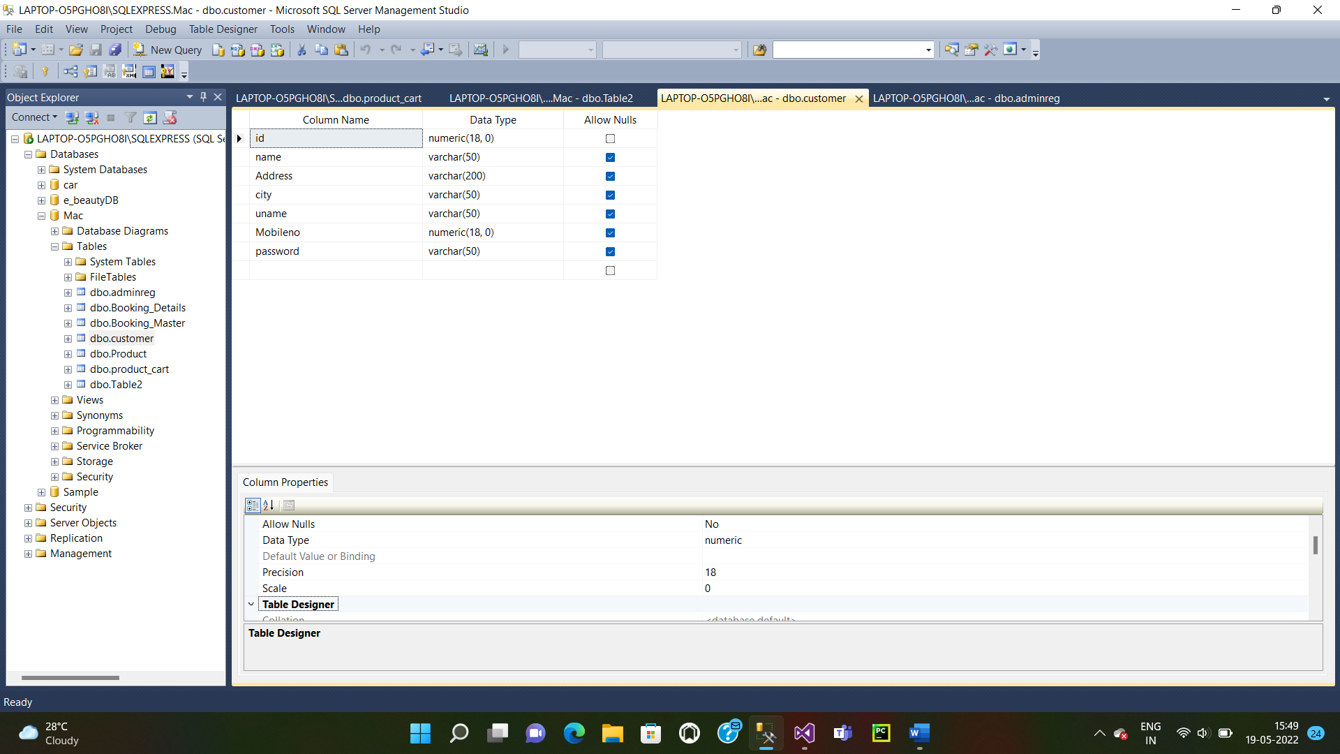

**Booking Master Table:**

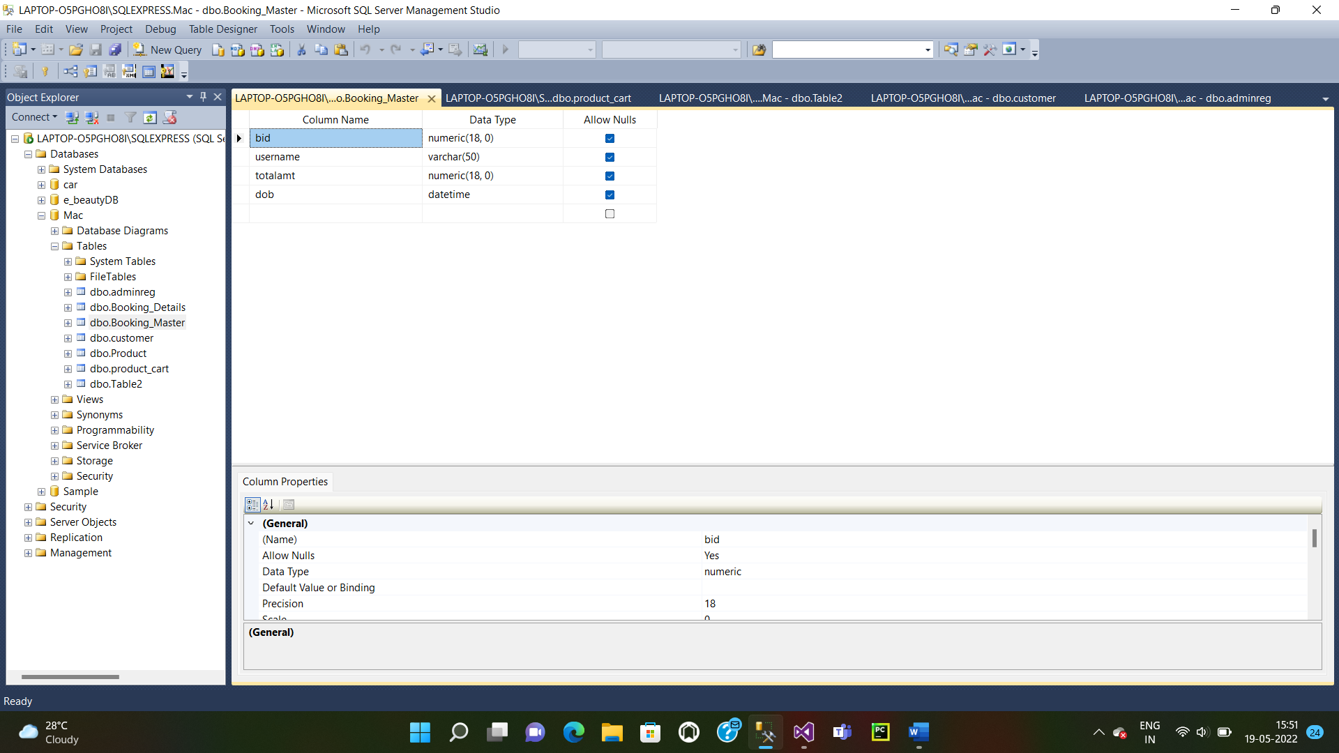

**Booking Details Table:**

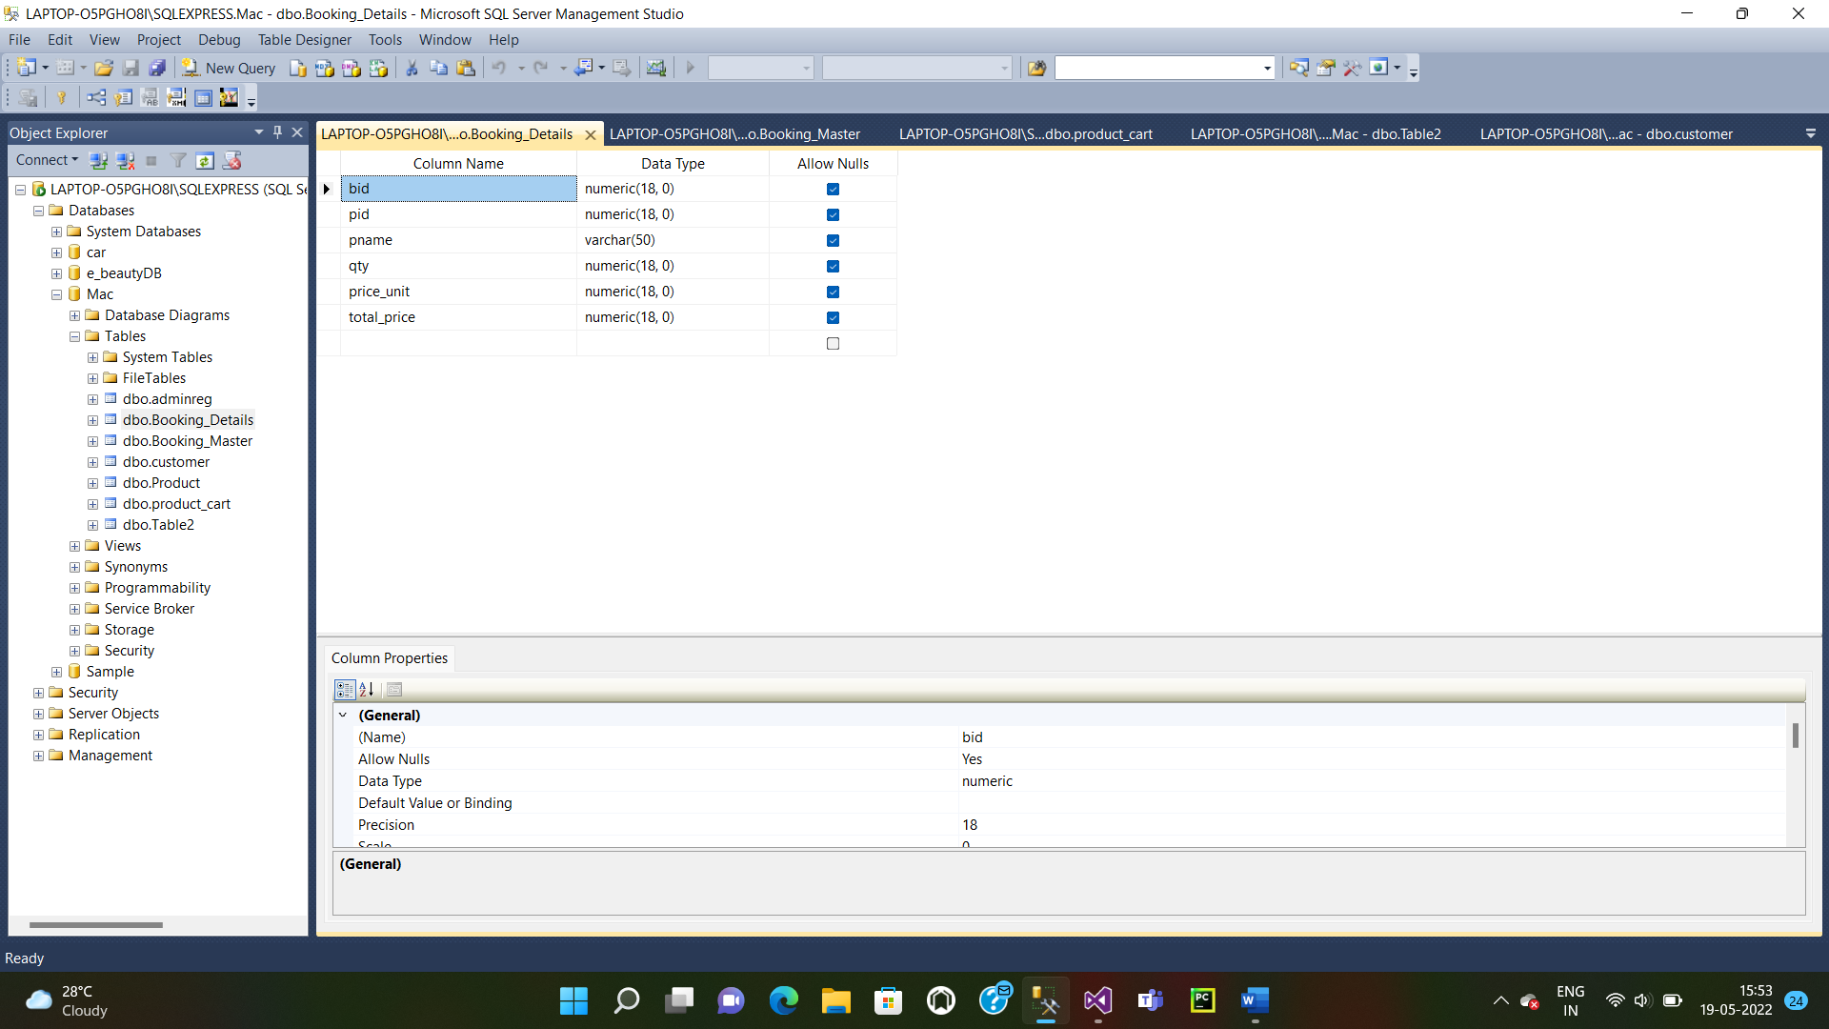

**Payment Details Table:**

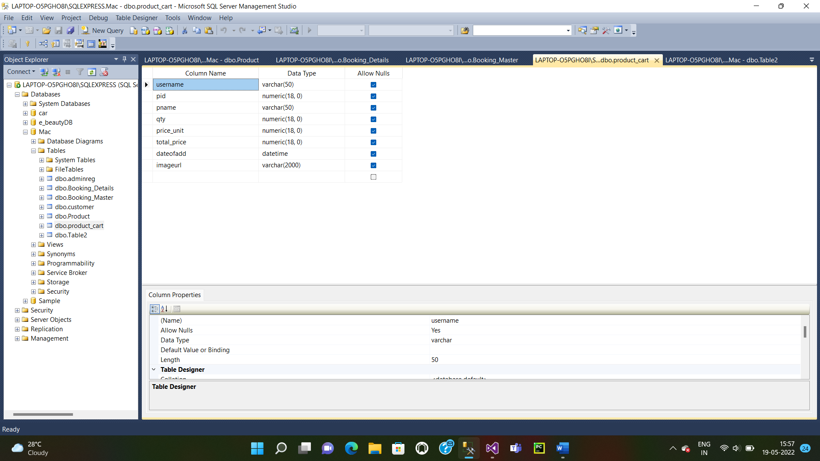

**UserManual**

1. **Home Page Form: -**

It consists of various links of the project.

1. **Customer Registration: -**

We can register the information of customer.

1. **Book Registration: -**

Here admin can add the book related information.

1. **Book Edit: -**

Here admin can update and delete the book related information.

1. **Book Booking: -**

Here customer can purchase the book.

1. **Book Cart:-**

Here customer can add which they want.

**Implementation**

Implementation plan is the process of converting a new or a revised system design number an operational one conversation is one aspect of implementation.

There are 3 types of implementation as follows:

1. Implementation of computer system to replace the manual.
2. Implementation of computer system to replace an existing system.
3. Implementation modified to replace an existing system.

**Bibliography**

**References:**

1. Programming with C# - Balgurusamy.
2. System Analysis and Design – Parthsarty.
3. Database System Concepts: KorthSilberschetz.

**Website:**

1. [www.tutorialspoint.com](http://www.tutorialspoint.com)
2. [www.oracletutorial.com](http://www.oracletutorial.com)
3. [www.guru99.com](http://www.guru99.com)